1. Create Database.

Ans: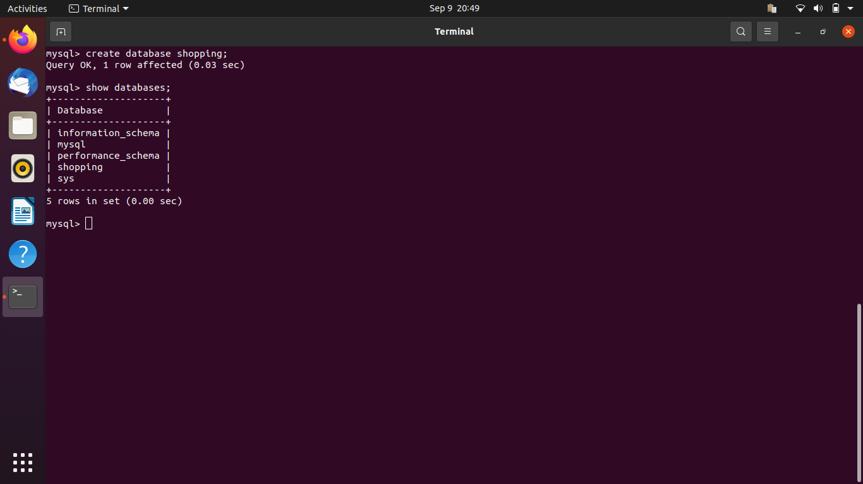

2.Design Schema

Ans : 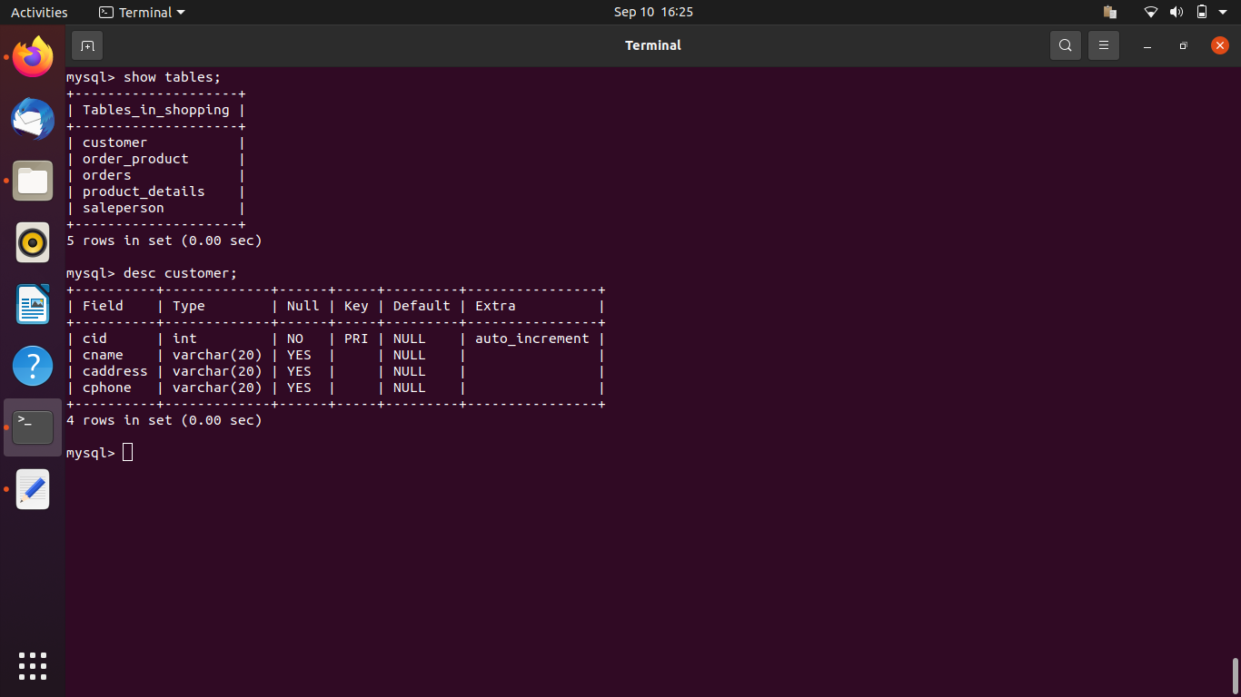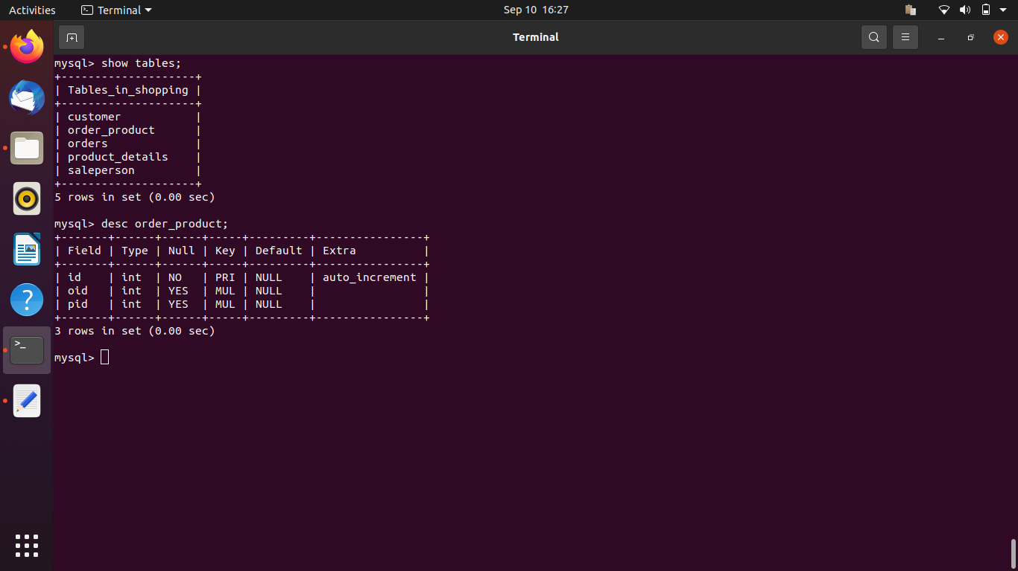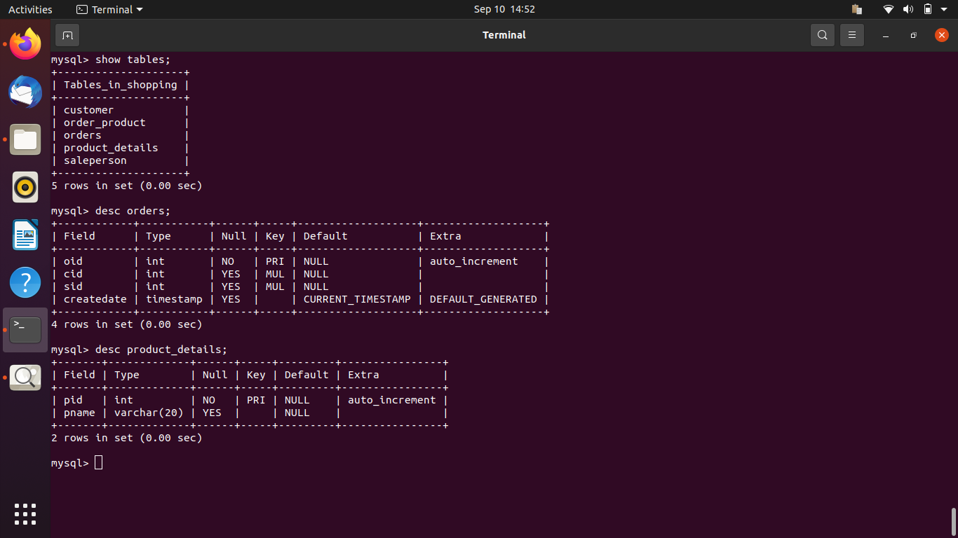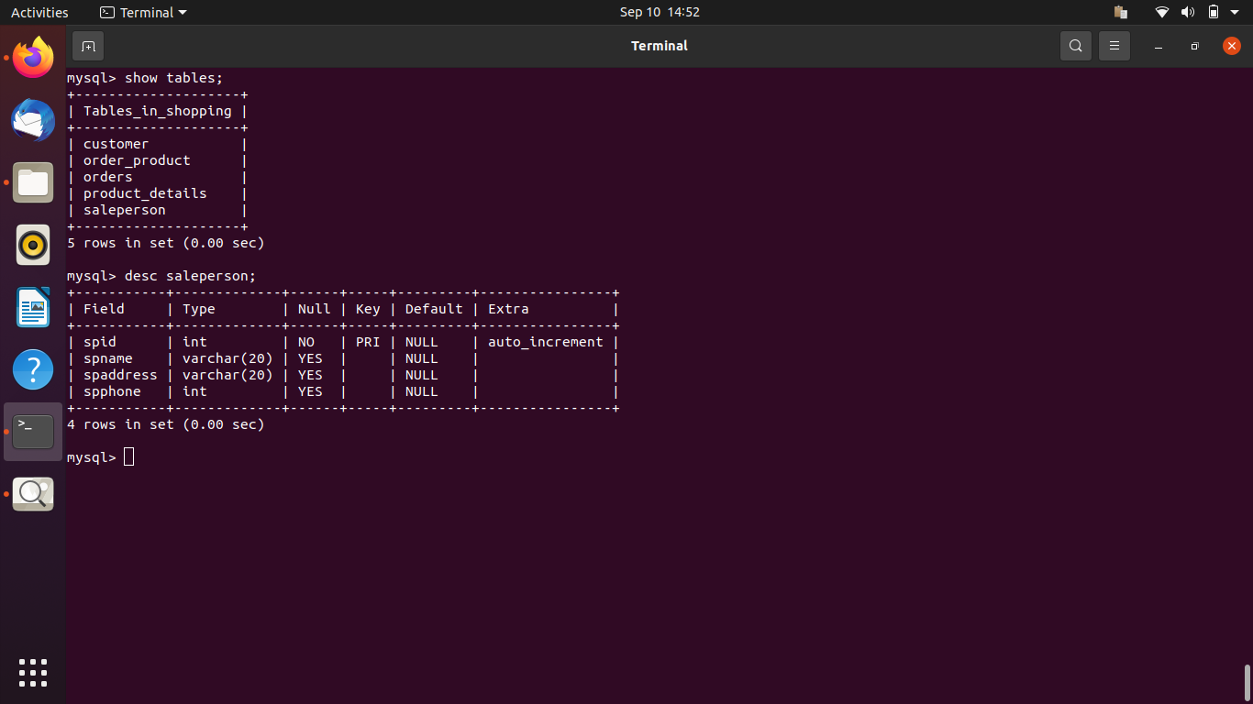

3. Create tables

Ans : CREATE TABLE `customer` (

`cid` int NOT NULL AUTO_INCREMENT,

`cname` varchar(20) DEFAULT NULL,

`caddress` varchar(20) DEFAULT NULL,

`cphone` varchar(20) DEFAULT NULL,

PRIMARY KEY (`cid`)

) ;

CREATE TABLE `order_product` (

`id` int NOT NULL AUTO_INCREMENT,

`oid` int DEFAULT NULL,

`pid` int DEFAULT NULL,

PRIMARY KEY (`id`),

KEY `fk_oid` (`oid`),

KEY `fk_pid` (`pid`),

CONSTRAINT `fk_oid` FOREIGN KEY (`oid`) REFERENCES `orders` (`oid`),

CONSTRAINT `fk_pid` FOREIGN KEY (`pid`) REFERENCES `product_details` (`pid`),

CONSTRAINT `order_product_ibfk_1` FOREIGN KEY (`oid`) REFERENCES `orders` (`oid`),

CONSTRAINT `order_product_ibfk_2` FOREIGN KEY (`pid`) REFERENCES `product_details` (`pid`)

);

CREATE TABLE `orders` (

`oid` int NOT NULL AUTO_INCREMENT,

`cid` int DEFAULT NULL,

`sid` int DEFAULT NULL,

`createdate` timestamp NULL DEFAULT CURRENT_TIMESTAMP,

PRIMARY KEY (`oid`),

KEY `fk_customer_id` (`cid`),

KEY `fk_sp_sid` (`sid`),

CONSTRAINT `fk_customer_id` FOREIGN KEY (`cid`) REFERENCES `customer` (`cid`),

CONSTRAINT `fk_sp_sid` FOREIGN KEY (`sid`) REFERENCES `saleperson` (`spid`)

);

CREATE TABLE `product_details` (

`pid` int NOT NULL AUTO_INCREMENT,

`pname` varchar(20) DEFAULT NULL,

PRIMARY KEY (`pid`)

) ;

CREATE TABLE `saleperson` (

`spid` int NOT NULL AUTO_INCREMENT,

`spname` varchar(20) DEFAULT NULL,

`spaddress` varchar(20) DEFAULT NULL,

`spphone` int DEFAULT NULL,

PRIMARY KEY (`spid`)

);

4. Insert sample data

Ans : 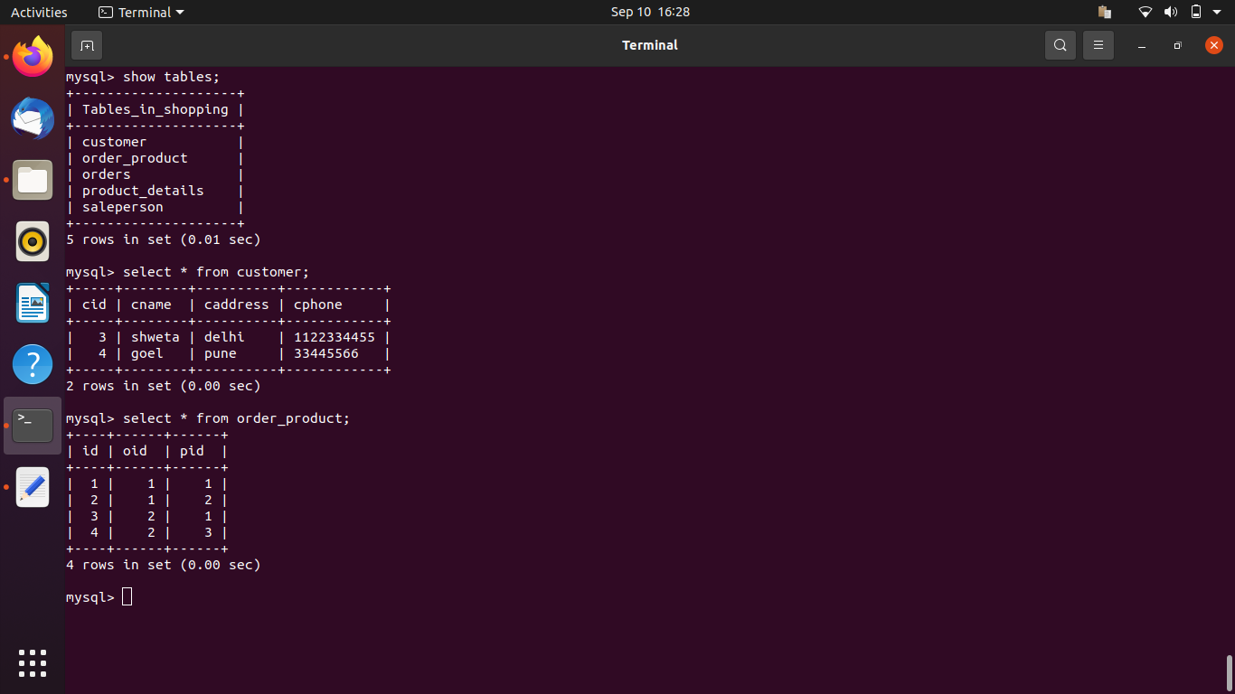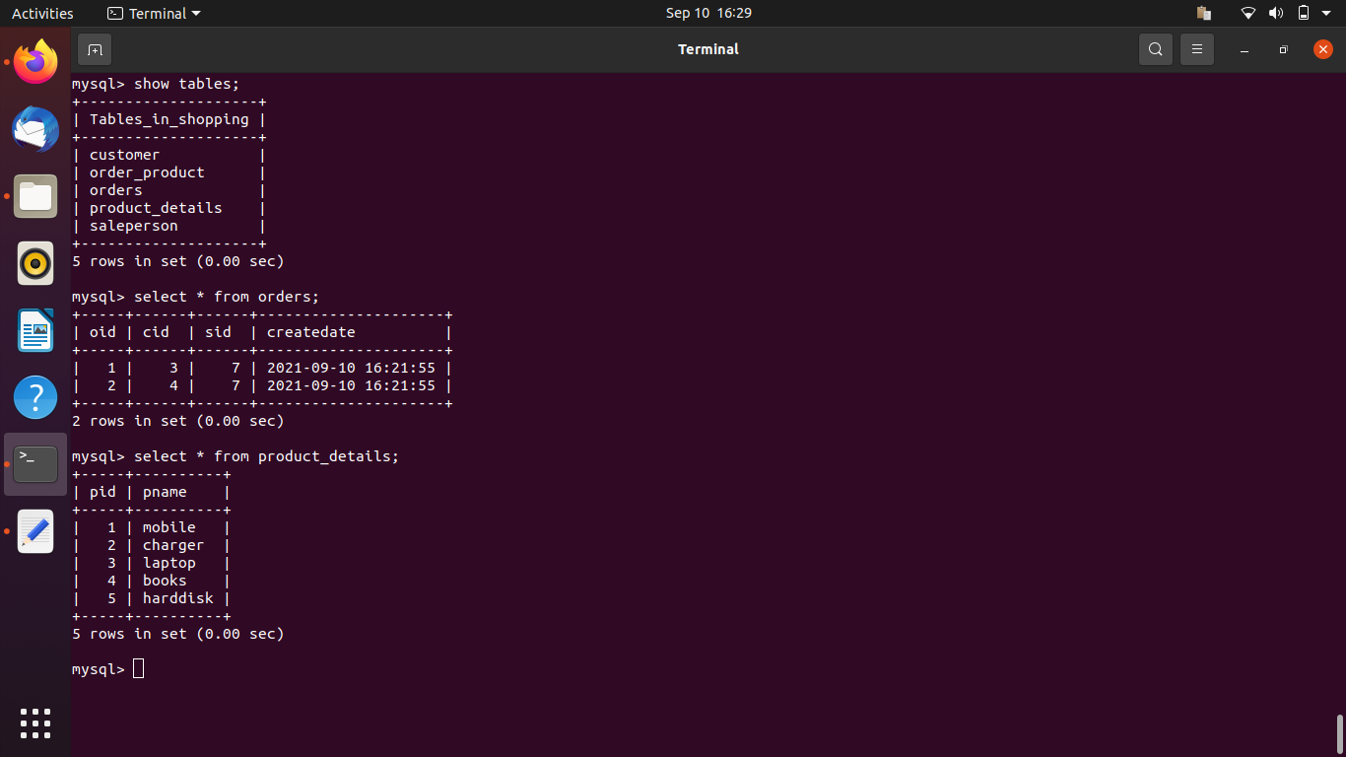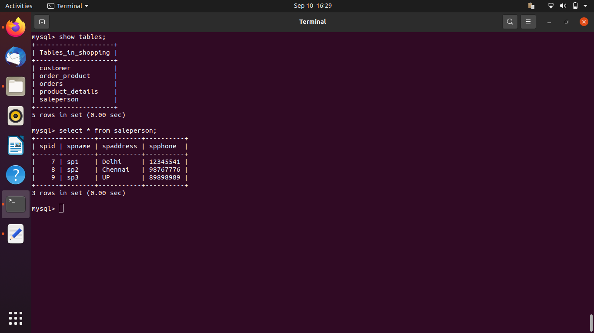

5. Find the sales person have multiple orders.

Ans :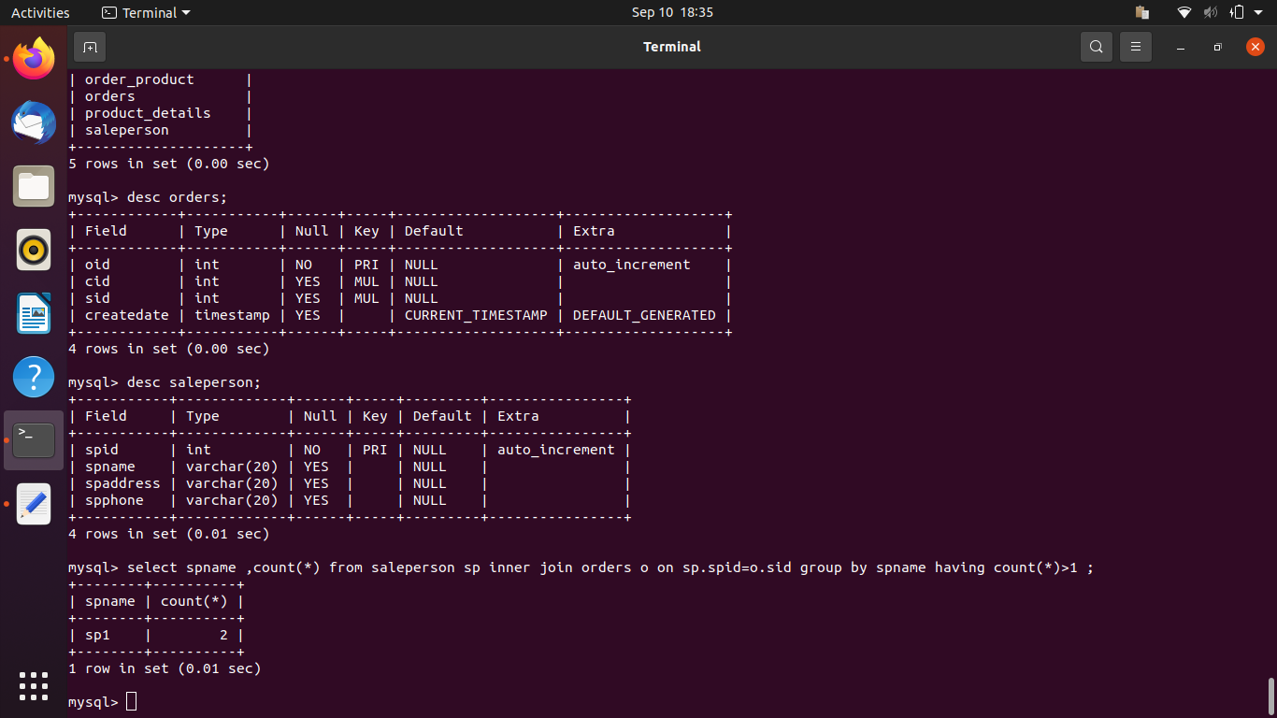

6. Find the all sales person details along with order details

Ans : 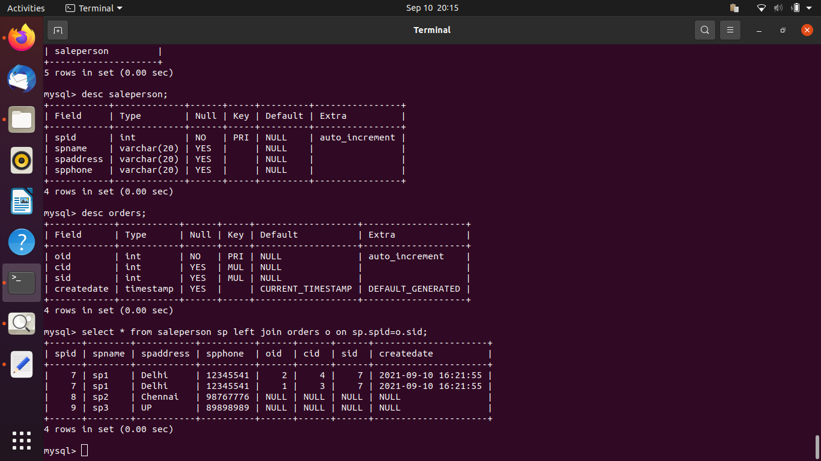

7. Create index.

Ans : 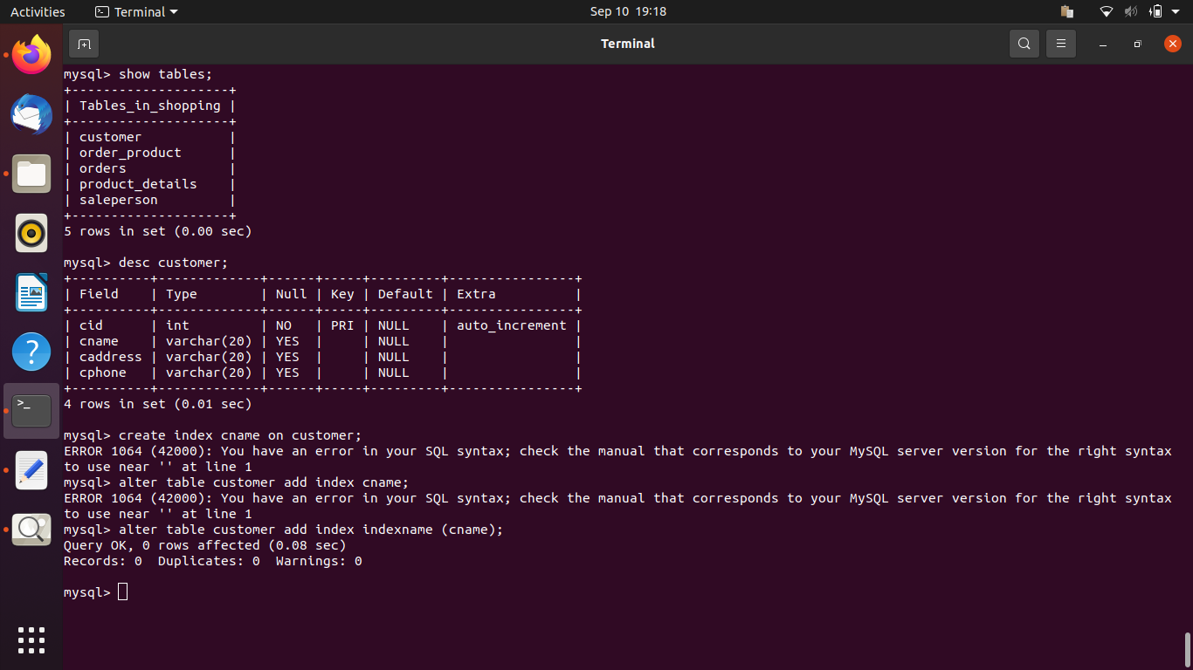

8. How to show index on a table.

Ans : 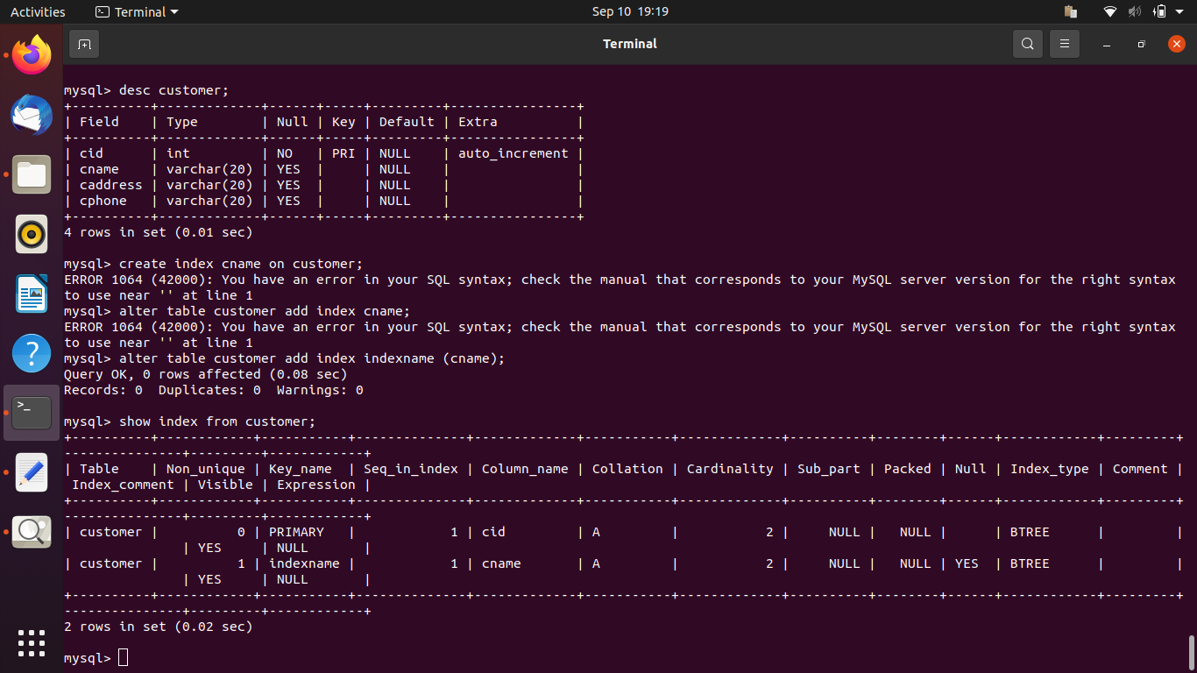

9. Find the order number, sale person name, along with the customer to whom that order belongs to.

Ans : 